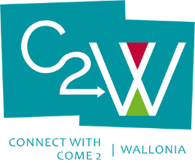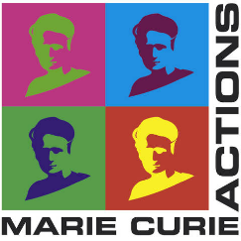**Post-doc position 24 months**

**International mobility**

**University of Mons – UMons**

**University of Namur - UNamur**

Two-year postdoctoral position on multiscale modelling of oxide powders in Li-ion battery materials

The University of Namur and University of Mons in Belgium have been jointly awarded a Marie-Curie COFUND project named “Come to Wallonia” (C2W) allowing them to hire in the next five years 30 postdoctoral fellows for a period of two years. The deadline for the first call is the 7th of March 2022 with an expected notification of acceptance in July 2022.

In this context, the groups of Prof. Stéphane Lucas at UNamur and Prof. Jérôme Cornil at UMons are jointly looking for a postdoctoral fellow interested to apply to this call for a project centered on the multiscale modelling of materials for Li-ion batteries.

More precisely, the main objective of the project is to model via Kinetic Monte Carlo (KMC) simulations the growth of carbon-based coatings on oxide powders used as cathodes in batteries.

The key originality of this project is to bridge the microscopic and macroscopic worlds by injecting in the KMC simulations relevant parameters (such as adsorption energies or diffusion barriers) independently evaluated at a quantum-chemical level.

Candidates should possess a solid background with atomistic theoretical simulations tools at the quantum and classical level and the will to work in a team spirit among the two research groups.

Most importantly, the candidates cannot have resided or carried out his/her main activity (work, studies…) in Belgium for more than 12 months in the three years before the deadline of the call).

They should send their CV to Stéphane Lucas ([stephane.lucas@unamur.ac.be](mailto:stephane.lucas@unamur.ac.be)) and Jérôme Cornil ([Jerome.Cornil@umons.ac.be](mailto:Jerome.Cornil@umons.ac.be)) before the end of January 2022.

|  |  |
| --- | --- |
|  |  |